

**Objective:**

Introduce/Re-evaluate methods for teachers to measure and evaluate course objectives based on data analysis

**Schedule:**

1. Data analysis and program evaluation
2. Methods for assessing measurement and evaluation
   1. Basic assessment evaluation (Example: Science placement test)
   2. Item analysis (Example: Science placement test)
   3. Discrimination index (Example: US Government final)
3. Academic plans for next year

**Reasons for data analyses (Bernhardt, 2004)**

* **Classroom instruction**
* Provide students with feedback on performance – student proficiency
* Gain a common understanding of what quality performance is and how close we are to achieving it
* Measure program success and effectiveness
* Understand if what we are doing is making a difference
* Make sure students “do not fall through the cracks”
* Discover root causes of issues seen in the classroom
* **Guide curriculum and revision**
* **Promote reflection and accountability**
* Meet district, state, and federal requirements

**Program evaluation (Bernhardt, 2004)**

1. Identify the purpose for the evaluation
   1. Develop a solution oriented statement

Example – How can I develop an ongoing system of measurement and evaluation in curriculum and instruction in………

1. Identify the audience
   1. Who are the results going to be used by?

McGuinness: Teachers, administration

1. Identify sources of information
   1. Multiple measures of data

McGuinness: Quantitative – grades, course assessment, test data, survey data

Qualitative – classroom observation, student feedback, survey information, peer feedback

1. **Conduct the assessment – this is today’s focus**

**What are steps I can take to get some immediate feedback from testing data.**

**- Assessment quality**

* 1. **What am I testing?**

**- Item analysis**

* 1. **How do the students’ perform on the assessment?**

**- Discrimination index**

* 1. **How well do the questions used on assessment chosen to specifically discriminate student performance assess what they are intended to assess.**

1. Communicate the results
   1. Communicate the results with stakeholders – department, faculty, administration

**Step One: Assessment Review – What is being tested?**

**Example: Science placement test**

1. Take curriculum objectives/study guide
2. Link questions to the objectives
3. Review item allocation with course goals
4. Address whether objectives that are not represented should be removed, replaced, or kept
5. Address whether a test could be failed based on one single objective
6. Correlate course objective with item (Has the objective been addressed in class? Was the content part of an activity at home with feedback provided?)

Overarching question: Do the items indicate student mastery based on specific standards?

**Science Placement Entrance Exam Review Sheet**

The following are the objectives and material that will be taught in the Methods of Science course. To test out of the course and into pre-AP biology you will need to demonstrate your ability or comprehension of the following. Please also be aware that you will be able to use a calculator, so bring your own. Also, the exam will be a combination of multiple-choice and writing.

1. Given a specific experimental context and quantity to measure, identify appropriate measurement tool.

Item 26

Item 28

Item 18

Item 51

Item 25

1. Solve word problems with scientific context by relating the given quantities with mathematical equations.

Item 20

1. Round the magnitude (numerical portion) of a measurement to the nearest whole number, tenth, hundredth, or thousandth, as specified.

Item 19

1. Perform one-step conversions between metric measurements (of length, mass, and volume) by relating decimal concepts to the metric system (including unit prefixes such as *kilo-, centi-, milli-*).

Item 14

Item 11

1. Solve problems involving measurements expressed in scientific notation. Convert numbers from standard decimal notation to scientific notation (and vice versa).

Item 17

1. Apply the method of dimensional analysis to convert measurements (of length, area, mass, and volume) both within and between the customary and metric systems.

Item not identified

1. Solve distance-rate-time problems in which two of three quantities are known.

Item 48

Item 49

Item 16

Item 47

Item 13

Item 46

1. Use a periodic table to solve problems involving the net electric charge of an ion and number of neutrons in a given isotope of an element.

Item 34

Item 57

Item 62

Item 59

Item 60

Item 58

Item 61

1. Write testable hypotheses in if/then format.

Item 1

1. Given a scientific experiment identify the dependent and independent variables, range of values, and units for measuring the variables in a collection of data.

Item not identified

1. Given a collection of data be able to represent the data in the most reasonable graphical form and include the following in the graph:
   1. Correct labeling of independent and dependent variables.
   2. Correct labels and units on X and Y-axes.
   3. Thorough, accurate and complete title that sufficiently describes graph so graph can be sufficiently understood without accompanying text.
   4. Ability to draw a “best fit” line if necessary.

Item 9

Item 4

Item 5

1. When given a scientific problem, students will be able to create an experiment and draw a conclusion. The experiment will contain the following essential components:

* If/then hypothesis that directs the experiment.
* Identifiable control group.
* Testing of only one variable at a time.
* Keeping all other variables constant.
* Correct identification of dependent variable and how it is measured.
* Experiment is repeated adequately for verification of results.
* Sensible conclusion/analysis of results.

Item 7

Item 8

Item 6

1. Given a scientific problem be able to create a data table that will enable a

researcher to collect data.

* Correct labeling and establishment of independent and dependent variables and units.
* Thorough, accurate and complete title that sufficiently describes the experiment.

Item 10

1. Use a periodic table to describe basic physical and chemical properties of an element, including identification of group, classification as metal, nonmetal, or metalloid, and phase at room temperature.

Item not identified

1. Explain how the graduations on equipment are used to write the magnitude of a measurement with the correct number of decimal places.

Item 12

1. Identify the name and function of at least twenty pieces of common lab equipment.

Item 22

Item 32

Item 15

Item 30

Item 31

Item 33

1. Define atom.

Item 44

1. Distinguish between elements and compounds.

Item not identified

1. Compare and contrast physical and chemical changes.

Item 29

1. Describe chemical changes with a chemical equation.

Item not identified

1. Determine how the law of conservation of matter applies to chemical changes.

Item 21

1. Explain how subatomic particles are arranged in an atom.

Item 39

Item 41

Item 38

Item 40

Item 35

Item 36

Item 37

1. Classify subatomic particles according to electrical charge.

Item 39

Item 41

Item 38

Item 40

Item 35

Item 36

Item 37

1. Define and explain the purpose of the strong nuclear and electromagnetic forces.

Item 45

1. Describe Rutherford and Thomson’s contributions to the history of atomic theory.

Item not identified

1. Explain significance of the structure of the periodic table.

Item 42

Item 43

1. Classify substances according to density.

Item 24

Item 23

Item 27

1. Calculate the volume of an irregularly shaped object by displacement.

Item not identified

1. Calculate the volume area of a solid object.

Item 52

1. Identify and explain why density is an intensive physical property.

Item 54

1. Solve mathematical problems involving density when two of three variables are known. Solve density problems in which at least one unit must be converted into other units. Solve density problems using dimensional analysis.

Item 53

1. Calculate wavelength, velocity, or frequency given two of the three variables. Solve wave problems using dimensional analysis.

Item 50

Item 55

Item 56

**Some points of discussion were evident in the science placement test?**

1. 14 questions out of 62 concerned subatomic particles
2. 7 questions out of 62 concerned the periodic table
3. 4 questions concerned identification of laboratory equipment
4. Questions types being used to test into pre-AP Biology neither reflected actual course questions nor covered material needed in the course
5. Multiple items on the study guide were not assessed on the test

**Result**

1. Completely redesigned test based on specific objectives related to testing out of Methods of Science
2. Reallocated items based on course objectives
3. Redesigned questions to reflect needs of a pre-AP Biology course
4. Effective assessment for success in pre-AP Biology

**Step Two: Item Analysis – Item Difficulty Index**

Reviewing each item on an assessment to determine how many students missed a particular item. General term for procedures designed to assess the usefulness of a test item.

The index of how many students got a question correct is known as the item difficulty index. Take the % correct and scale it from 0 to 1. So if 54% of students got it correct the answer difficulty index would be 0.54.

There are “desirable difficulty levels” for norm-referenced tests (Lord, 1952).

5 items 0.7

4 item 0.74

3 items 0.77

True/False 0.85

**Purpose of item analysis (Runte, 2014)**

General purpose

- Find flaws in the test so that you can adjust before returning to students.

- Find questions with two right answers, or that were too hard, etc., that you may want to drop from the exam.

- More diagnostic information on students

- Curriculum feedback

Classroom level

- Potential to identify questions they were are all guessing on

- Potential to find questions that students had difficulty with so you can reteach that concept

- Ability to use basic descriptive statistics to compare individual achievement with classroom performance. Example: Notre Dame assessment model

- Build future tests

- Revise test items, build question bank

Individual level

- Isolate specific errors a student has made and individualize instruction

**Basic example**

* Kyocera machine will provide this feedback on multiple-choice assessments and give you the item difficulty index (see example).
* Can also be used on free response assessments by conducting an analysis on the rubric used to grade the essay/short answer etc.
* Use Kyocera print out that addresses each question.
* Greater clarity on how the items are being perceived by students by grouping them according to the objective
* Can be expanded by looking at comparison with other descriptive statistics on the test
* Compare items within the same objective
* As the professional use personal judgment in addressing results
  + Why might an item have a 100% correct or 0% correct?
  + Why would a question have a 50/50 split between two answers?
  + What has occurred when each potential answer has the same number of answers?

1. Given a specific experimental context and quantity to measure, identify appropriate measurement tool.

Item 26 Item difficulty index 0.375

Item 28 Item difficulty index 0.5

Item 18 Item difficulty index 0.625

Item 51 Item difficulty index 0.625

Item 25 Item difficulty index 0.75

1. Solve word problems with scientific context by relating the given quantities with mathematical equations.

Item 20 Item difficulty index 0.875

1. Round the magnitude (numerical portion) of a measurement to the nearest whole number, tenth, hundredth, or thousandth, as specified.

Item 19 Item difficulty index 0.25

1. Perform one-step conversions between metric measurements (of length, mass, and volume) by relating decimal concepts to the metric system (including unit prefixes such as *kilo-, centi-, milli-*).

Item 14 Item difficulty index 0.375

Item 11 Item difficulty index 0.625

1. Solve problems involving measurements expressed in scientific notation. Convert numbers from standard decimal notation to scientific notation (and vice versa).

Item 17 Item difficulty index 1.0

1. Apply the method of dimensional analysis to convert measurements (of length, area, mass, and volume) both within and between the customary and metric systems.

Item not identified

1. Solve distance-rate-time problems in which two of three quantities are known.

Item 48 Item difficulty index 0.125

Item 49 Item difficulty index 0.125

Item 16 Item difficulty index 0.375

Item 47 Item difficulty index 0.75

Item 13 Item difficulty index 0.875

Item 46 Item difficulty index 0.875

1. Use a periodic table to solve problems involving the net electric charge of an ion and number of neutrons in a given isotope of an element.

Item 34 Item difficulty index 0.0

Item 57 Item difficulty index 0.0

Item 62 Item difficulty index 0.0

Item 59 Item difficulty index 0.125

Item 60 Item difficulty index 0.25

Item 58 Item difficulty index 0.375

Item 61 Item difficulty index 0.5

1. Write testable hypotheses in if/then format.

Item 1 Item difficulty index 0.625

1. Given a scientific experiment identify the dependent and independent variables, range of values, and units for measuring the variables in a collection of data.

Item not identified

1. Given a collection of data be able to represent the data in the most reasonable graphical form and include the following in the graph:
   1. Correct labeling of independent and dependent variables.
   2. Correct labels and units on X and Y-axes.
   3. Thorough, accurate and complete title that sufficiently describes graph so graph can be sufficiently understood without accompanying text.
   4. Ability to draw a “best fit” line if necessary.

Item 9 Item difficulty index 0.375

Item 4 Item difficulty index 0.675

Item 5 Item difficulty index 0.675

1. When given a scientific problem, students will be able to create an experiment

and draw a conclusion. The experiment will contain the following essential

components :

* If/then hypothesis that directs the experiment.
* Identifiable control group.
* Testing of only one variable at a time.
* Keeping all other variables constant.
* Correct identification of dependent variable and how it is measured.
* Experiment is repeated adequately for verification of results.
* Sensible conclusion/analysis of results.

Item 7 Item difficulty index 0.75

Item 8 Item difficulty index 0.75

Item 6 Item difficulty index 0.875

1. Given a scientific problem be able to create a data table that will enable a

researcher to collect data.

* Correct labeling and establishment of independent and dependent variables and units.
* Thorough, accurate and complete title that sufficiently describes the experiment.

Item 10 Item difficulty index 0.75

1. Use a periodic table to describe basic physical and chemical properties of an element, including identification of group, classification as metal, nonmetal, or metalloid, and phase at room temperature.

Item not identified

1. Explain how the graduations on equipment are used to write the magnitude of a measurement with the correct number of decimal places.

Item 12 Item difficulty index 0.875

1. Identify the name and function of at least twenty pieces of common lab equipment.

Item 22 Item difficulty index 0.25

Item 32 Item difficulty index 0.5

Item 15 Item difficulty index 0.675

Item 30 Item difficulty index 0.75

Item 31 Item difficulty index 0.875

Item 33 Item difficulty index 0.875

1. Define atom.

Item 44 Item difficulty index 1.0

1. Distinguish between elements and compounds.

Item not identified

1. Compare and contrast physical and chemical changes.

Item 29 Item difficulty index 1.0

1. Describe chemical changes with a chemical equation.

Item not identified

1. Determine how the law of conservation of matter applies to chemical changes.

Item 21 Item difficulty index 0.125

1. Explain how subatomic particles are arranged in an atom.

Item 39 Item difficulty index 0.75

Item 41 Item difficulty index 0.75

Item 38 Item difficulty index 0.875

Item 40 Item difficulty index 0.875

Item 35 Item difficulty index 1.0

Item 36 Item difficulty index 1.0

Item 37 Item difficulty index 1.0

1. Classify subatomic particles according to electrical charge.

Item 39 Item difficulty index 0.75

Item 41 Item difficulty index 0.75

Item 38 Item difficulty index 0.875

Item 40 Item difficulty index 0.875

Item 35 Item difficulty index 1.0

Item 36 Item difficulty index 1.0

Item 37 Item difficulty index 1.0

1. Define and explain the purpose of the strong nuclear and electromagnetic forces.

Item 45 Item difficulty index 0.5

1. Describe Rutherford and Thomson’s contributions to the history of atomic theory.

Item not identified

1. Explain significance of the structure of the periodic table.

Item 42 Item difficulty index 0.0

Item 43 Item difficulty index 0.25

1. Classify substances according to density.

Item 24 Item difficulty index 0.75

Item 23 Item difficulty index 1.0

Item 27 Item difficulty index 1.0

1. Calculate the volume of an irregularly shaped object by displacement.

Item not identified

1. Calculate the volume area of a solid object.

Item 52 Item difficulty index 0.875

1. Identify and explain why density is an intensive physical property.

Item 54 Item difficulty index 0.375

1. Solve mathematical problems involving density when two of three variables are known. Solve density problems in which at least one unit must be converted into other units. Solve density problems using dimensional analysis.

Item 53 Item difficulty index 0.75

1. Calculate wavelength, velocity, or frequency given two of the three variables. Solve wave problems using dimensional analysis.

Item 50 Item difficulty index 0.375

Item 55 Item difficulty index 0.5

Item 56 Item difficulty index 1.0

**Optional Step Three: Discrimination Index**

In step two we looked at the item-difficulty index (p). This index is determined by calculating the proportion of examinees that answer the item correctly.

In step three we are looking at a second index called the item-discrimination index (d). For this calculation, we divide the test takers into three groups according to their scores on the test as a whole: an upper group consisting of the 27% who make the highest scores, a lower group consisting of the 27% who make the lowest scores, and a middle group consisting of the remaining 46%.

The discrimination index is a useful measure of item quality whenever the purpose of a test is to produce a spread of scores, reflecting differences in student achievement, so that distinctions may be made among the performances of examinees (https://msu.edu/dept/soweb/indexdis.html).

**Formula**



*Up* = number of test takers in the upper group that got the item correct

*Lp* = number of test takers in the lower group that got the item correct

*U* = the total number of test takers in the upper group

As an example, assume that 50 people take a test. For the difficulty index, 27 test-takers answer the item correctly. For the discrimination index, the upper and lower groups will be formed from the top 14 and bottom 14 test takers on total test score. If 12 of the test takers in the upper group and 7 of those in the lower group pass the item, then:

**Difficulty index**



**Discrimination index**



(Examples taken from the Valdosta University College of Education <http://mypages.valdosta.edu/mwhatley/3900/itemanalysis.pdf>)

**How to interpret the discrimination index?**

- Discrimination index is near the maximum possible = very discriminating item

- Discrimination index is about half the maximum possible = moderately discriminating item

- Discrimination index is about a quarter the maximum possible = weak discriminating item

- Discrimination index is near zero = non-discriminating item

- Discrimination index is negative = bad item (delete it if worse than -.10)

(University of Delaware, 2016)

**Example using the AP US Government Final**

Question 1 identified by Ms. Collins as easy

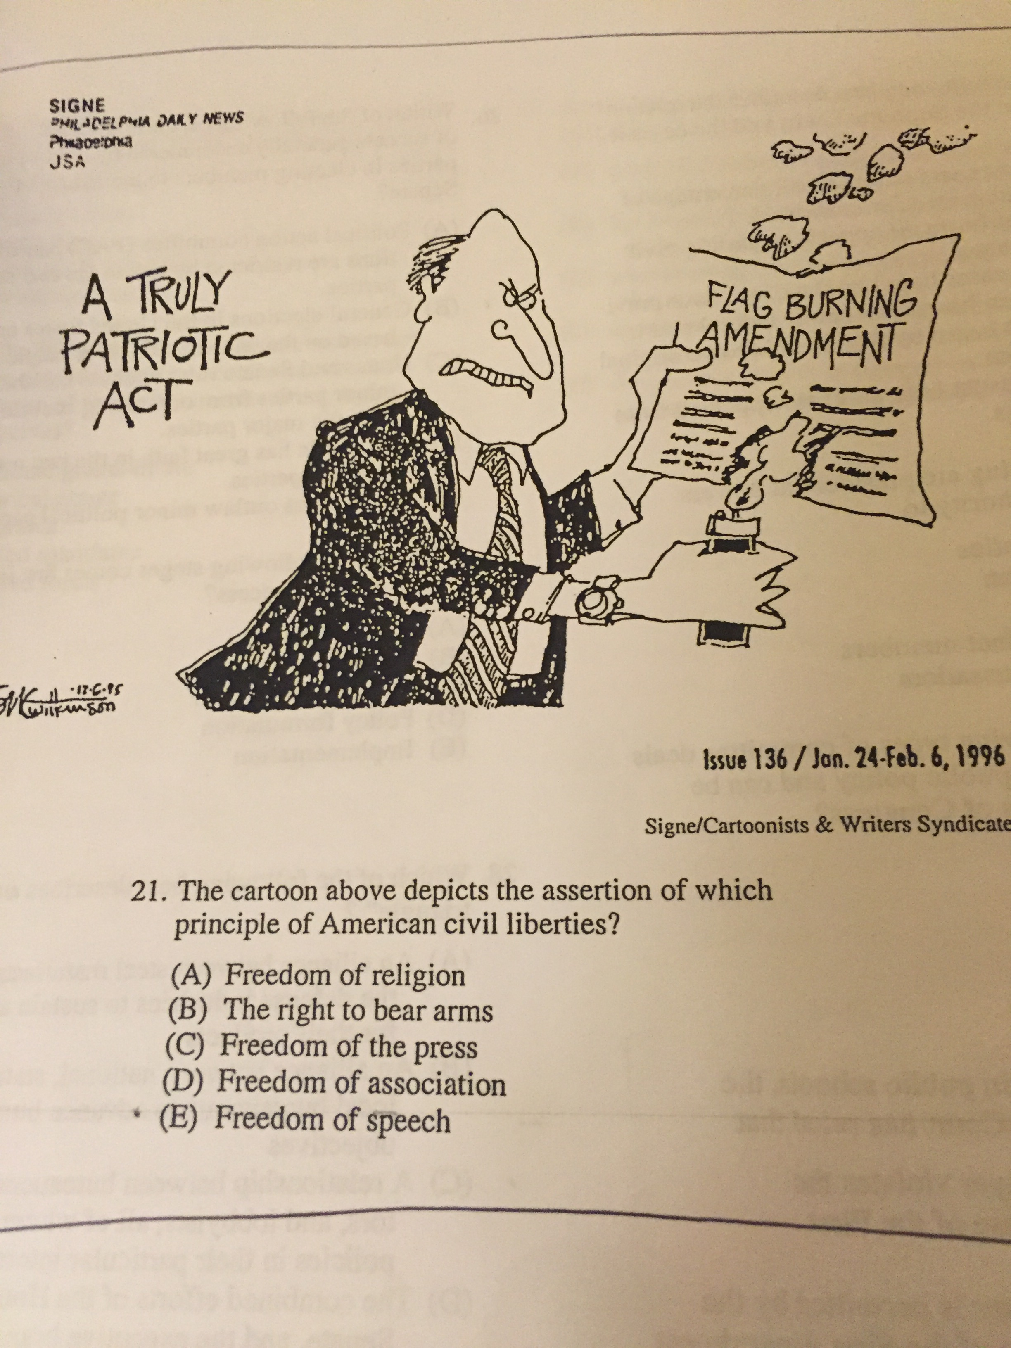



Question 2 identified by Ms. Collins as moderate

If a college’s admission policy to reserve twenty seats in its incoming class for applicants belonging to racial minority groups is challenged in the courts, a judge is likely to

1. uphold the policy because it provides additional opportunities for minority applicants
2. strike down the seat policy because reserving seats amounts to a quota system
3. strike down the policy because the percentage of seats reserved is less that the percentage of minority citizens in the general population
4. uphold the policy because only a small percentage of the total seats for incoming students are affected
5. strike down the policy because it did not apply to women as well as racial minorities



Question 3 identified by Ms. Collins as difficult

Which of the following powers are shared by the House of Representatives and the Senate?

1. Holding trials of impeachment
2. Establishing federal courts
3. Approving treaties
4. Holding confirmation hearings
5. Approving major presidential appointments



**Note: Notre Dame Recommendations for Traditional Test**

80% of questions should be attainable by all students

**On a 100 point test**

**45 points**

“Straightforward questions about the connections among the units lesson concepts and skills”

**15 points**

“1st semester. Straightforward questions about the connections between the unit’s lesson concepts and previous units’ enduring understanding.

2nd semester. Questions that assess Course and T/D Outcomes

Both semesters: Straightforward content literacy questions.”

**20 points**

“Straightforward questions that address the unit goal/concept”

**10 points**

“More challenging questions that address the unit goal/concept”

**10 points**

“Sophisticated questions that address the unit goal/concept”